Certificate No.:
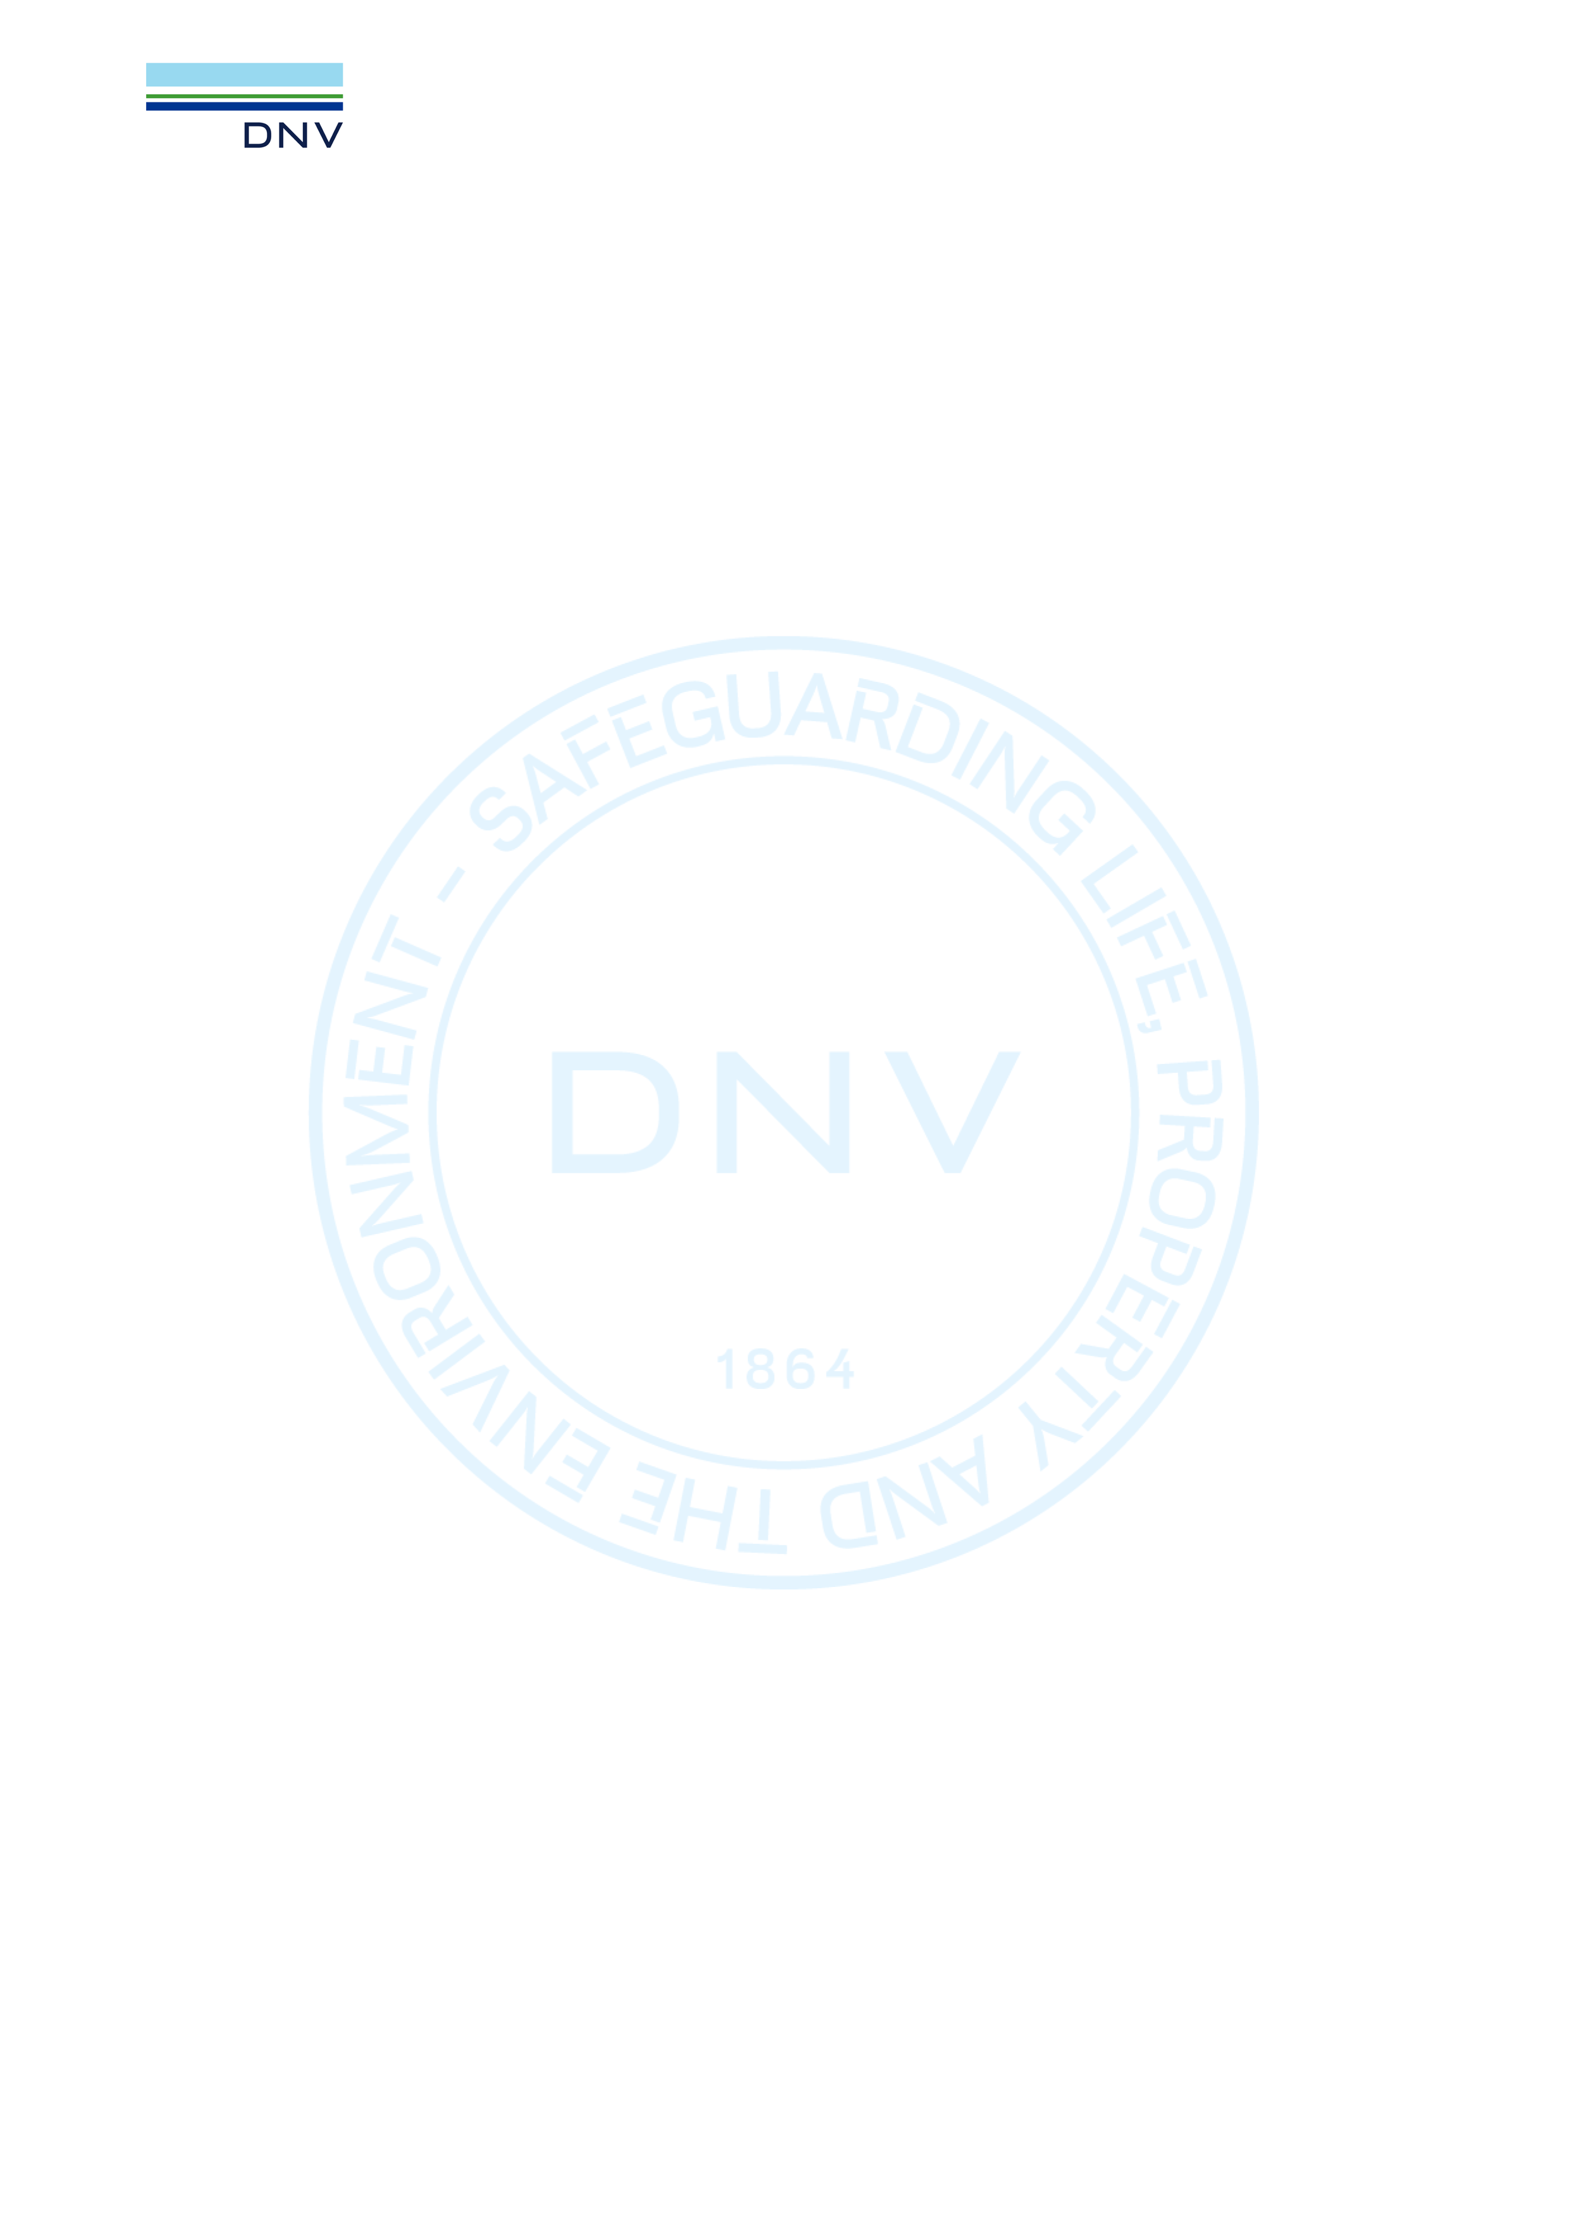

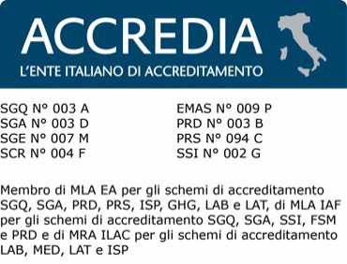
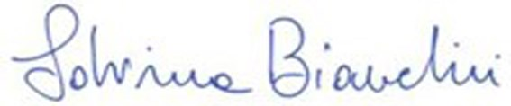


10000473485-MSC-ACCREDIA-ESP Audit date:
29.04.2025 - 30.04.2025
Certificate Issue date: 11.06.2025
Certificate Expiry Date: 15.06.2026
Date and place:
12.06.2025, Vimercate
Next Recertification audit to be performed within the time period between:
24.02.2026 and 05.05.2026 (announced audit)
30.12.2025 and 05.05.2026 (unannounced audit)

Herewith the certification body DNV Business Assurance Italy S.r.l. being an ISO/IEC 17065 accredited certification body for IFS Certification and having signed an agreement with IFS Management GmbH, confirms that the processing activities of

Harinera Canaria S.A.
C/ los Cactus n.5, 35118 Agüimes - Las Palmas, Spain
COID: 82037 - GS1 GLN(s): 8437009528006
Sanitary legal authorisation number: 20.09483-GC, 40.076031-GC

for the audit scope:
Molienda de harina de trigo y salvado de trigo y envasado en sacos de celulosa o a granel. Mezclado de harinas especiales a base de harinas de trigo y otros cereales (harina de centeno, maíz) y semillas, envasados en sacos de celulosa.
additional information:
Exclusions: Wheat bran granulated or not for animal feed
The company has own broker activities which are not certified, according to IFS or another GFSI recognised standard. Product scopes: 6 Grain products, cereals, industrial bakery and pastry, confectionary, snacks Technology scopes: D, F

meet the requirements set out in the
IFS Food Version 8, April 2023 and other associated normative documents
Passed at Higher Level with a score of 98.63 %
Date of the last unannounced audit (last day of the audit):23.01.2024

For the Certification Body: Sabrina Bianchini:

Address of the Certification Body: DNV Business Assurance Italy S.r.l., Via Energy Park, 14, 20871 Vimercate (MB), Italy Lack of fulfilment of conditions as set out in the Certification Agreement may render this Certificate invalid.
Any changes in the product shall immediately be reported to DNV Business Assurance Italy S.r.l. in order to verify whether this certificate remains valid.

